DABUUS NURSERY AND PRIMARY SCHOOL
SCHEME OF WORK FOR BABYCLASS – GENERAL KNOWLEDGE TERM III 2023
W  K | PD | LEARNING OUTCOME | MAJOR COMPETENCE | SPECIFIC COMPETENCE | CONTENT | ACTIVITIES | METHODS | T/L AIDS | REF | REM
1 | 1 | Caring for my body parts | I can protect and care r my body. | I can name the body parts orally | Name the body parts orally.  i.e.  head  hands  nose | - Naming the body parts | Look and say | Real objects | Lfw page 33
1 | 2 | Caring for my body parts | I can protect and care r my body. | I can name and shade things used to clean the body. | Name and shade the things used to clean the body. | - Naming  - Shading | Demonstration | Real objects | Lfw page 33
2 | 1 | Identifying dangers in my environment and taking precaution | I can recognize dangerous things and situation in my environment. | I can name and match the same dangerous things | Match the same dangerous objects. | - Matching | Look and say | Real objects | Lfw page 31
2 | 2 | Identifying dangers in my environment and taking precaution | I can protect and care for my body | I can protect and care for my body. | Shade the things we wear.  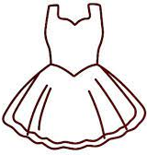  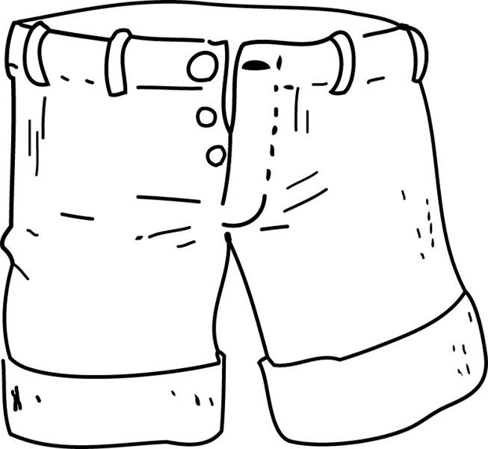 | - Shading  - Naming
3 | 1 | Identifying taking interest in and observing our environment | I can identify food that is good for my health | I can name the types of food. | Match the same food. | - Naming  - Matching | Guided discovery | Real objects | Lfw page 15
3 | 2 | Identifying taking interest in and observing our environment | I can identify food that is good for my health | I can name the types of food. | Name and draw the food we eat. | - Naming  - Drawing | Guided discovery | Real objects | Lfw page 15
4 | 1 | Knowing and appreciating important places in my environment | I can talk about important places in my environment. | I can talk about important places in my environment | 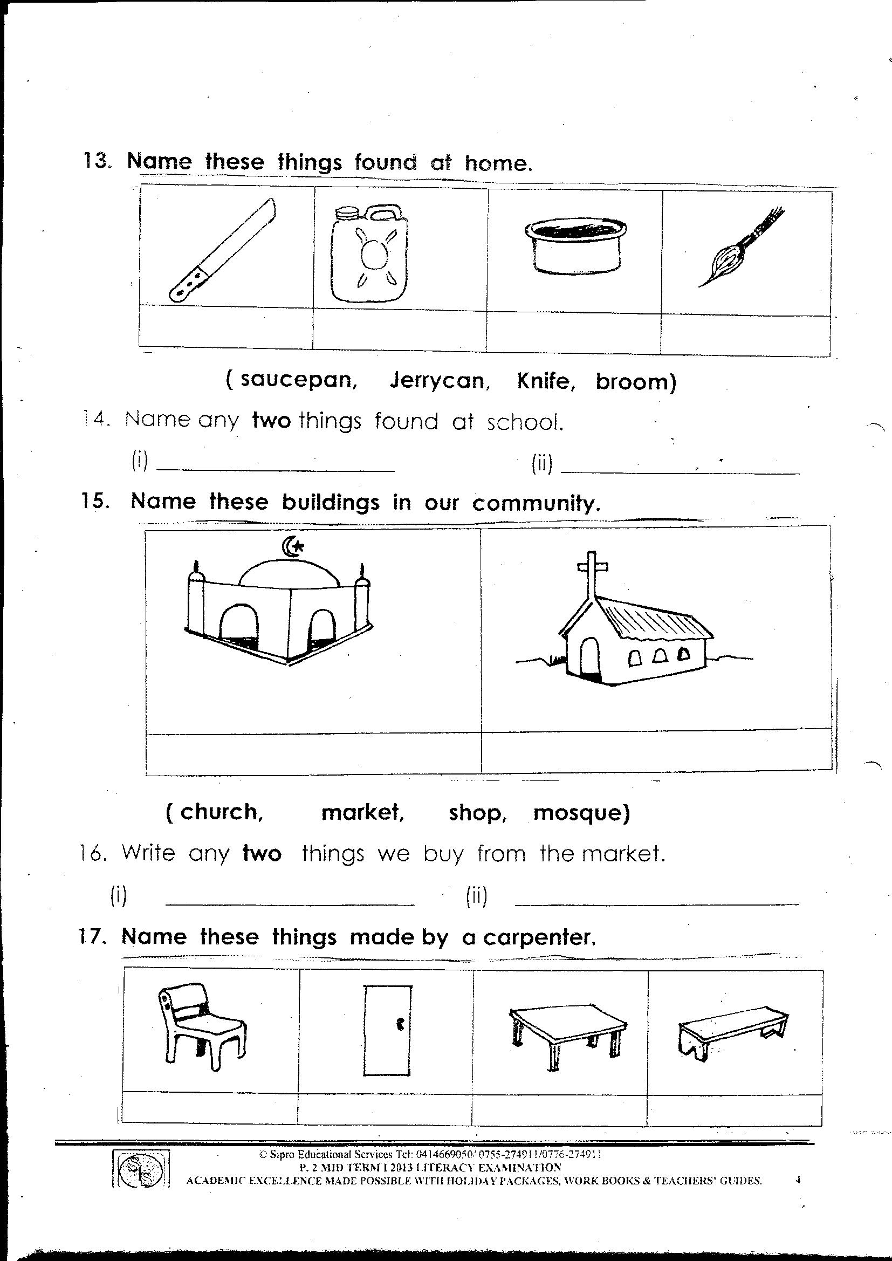  Name and shade the important places i.e.  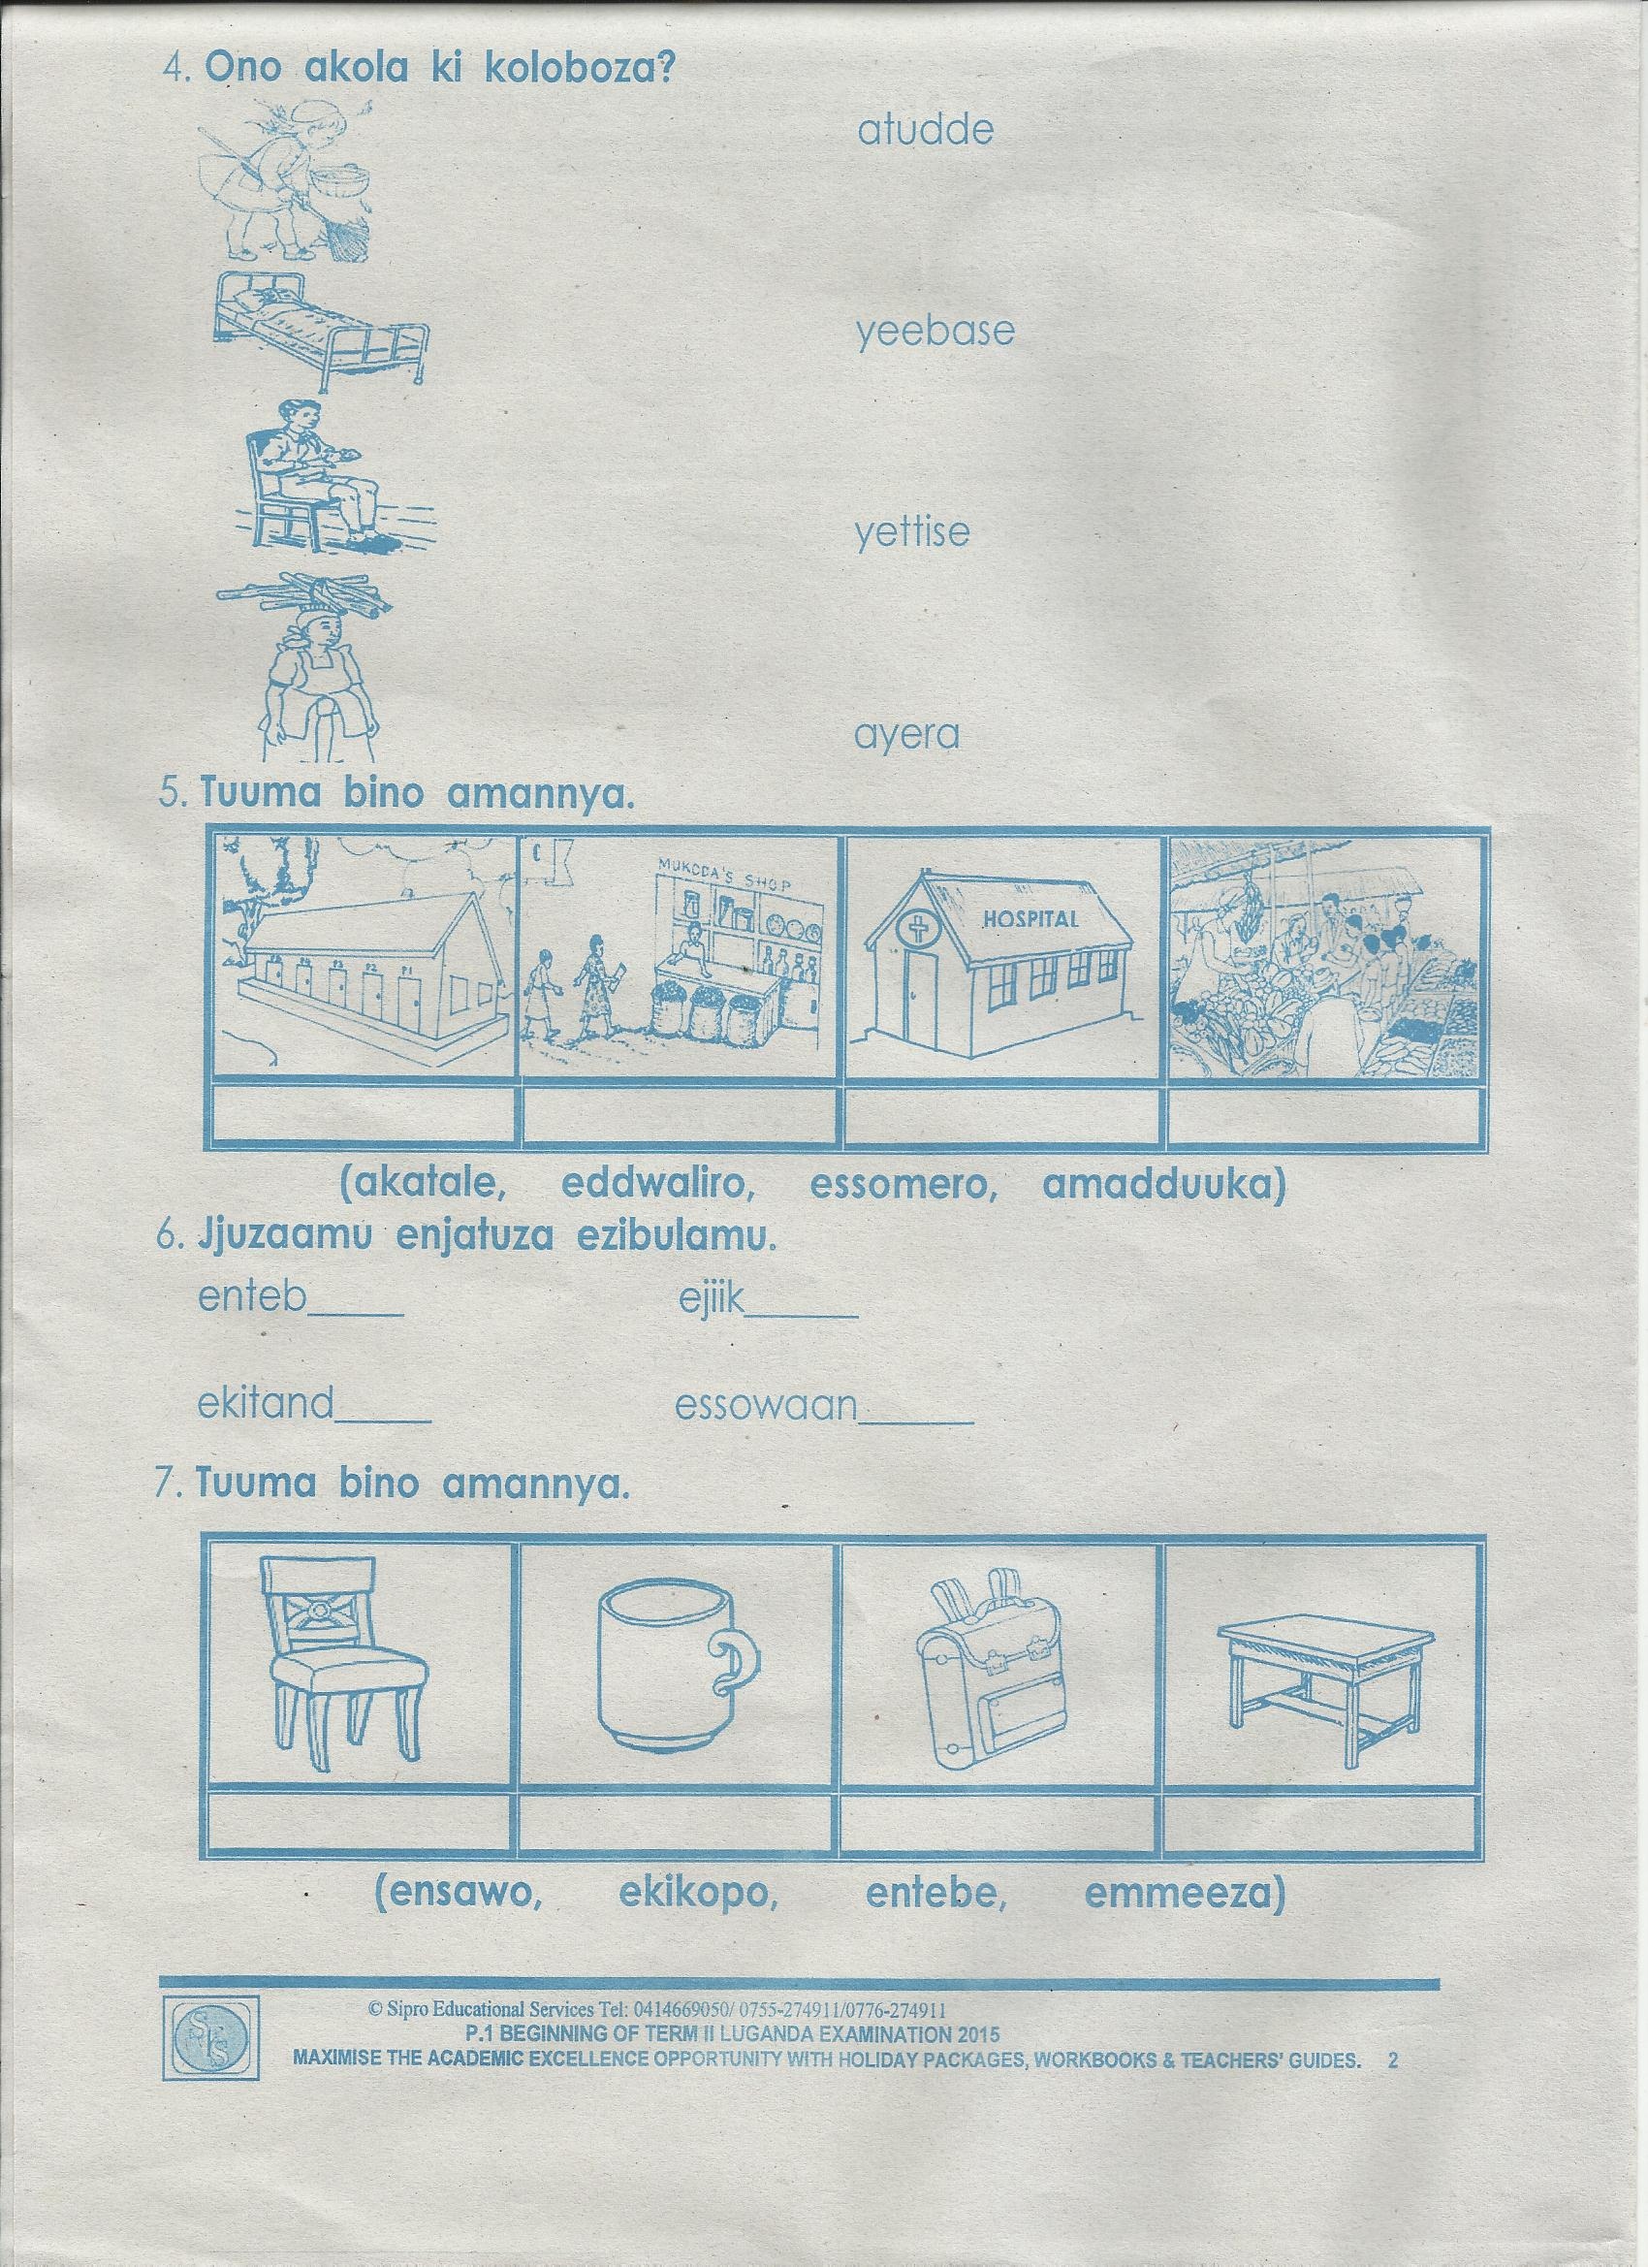 | - Naming  - Shading | Look and say | A chart with important places
4 | 2 | Knowing and appreciating important places in my environment | I can talk about important places in my environment. | I can talk about important places in my environment | Match the same important places | - Naming  - Shading | Look and say | A chart with important places
5 | 1 | Exploring and knowing my immediate environment | I can name animals at home orally and their uses. | I can name and shade animals at home and their uses. | Name and shade the animals at home. | - Naming  - Shading |  | A chart with domestic animals
5 | 2 | Exploring and knowing my immediate environment | I can name animals at home orally and their uses. | Name animals at home and their uses orally i.ee. cow | Match the same animals | - Naming | Look and say | A chart for animals | Lfw page
6 | 1 | Exploring and knowing my immediate environment | I can identify people, plants and other things at the learning centre. | I can name things in the class orally and their uses. | Colour | - Naming things found in the class and their uses. | Explanation  Guided discovery | Real objects | Lfw page 55
6 | 2 | Exploring and knowing my immediate environment |  | I can name things in the class orally and their uses. | Copying | - Copying things found in class | Look and say |  | Lfw page 55
7 | 1 | Exploring and knowing my immediate environment | I can talk about important places in my environment. | I can name and shade things at home. | Match the same things at home. | - Matching | Demonstration | A chart with things at home. | Lfw page 55
7 | 2 | Exploring and knowing my immediate environment | I can talk about important places in my environment. | I can name and shade things at home. | Copy the things at home. | - Copying | Look and say | A chart with things at home. | Lfw page 20
8 | 1 | Identifying taking interest in and observing our environment | I can identify food that is good for my health. | I can tell the weather | 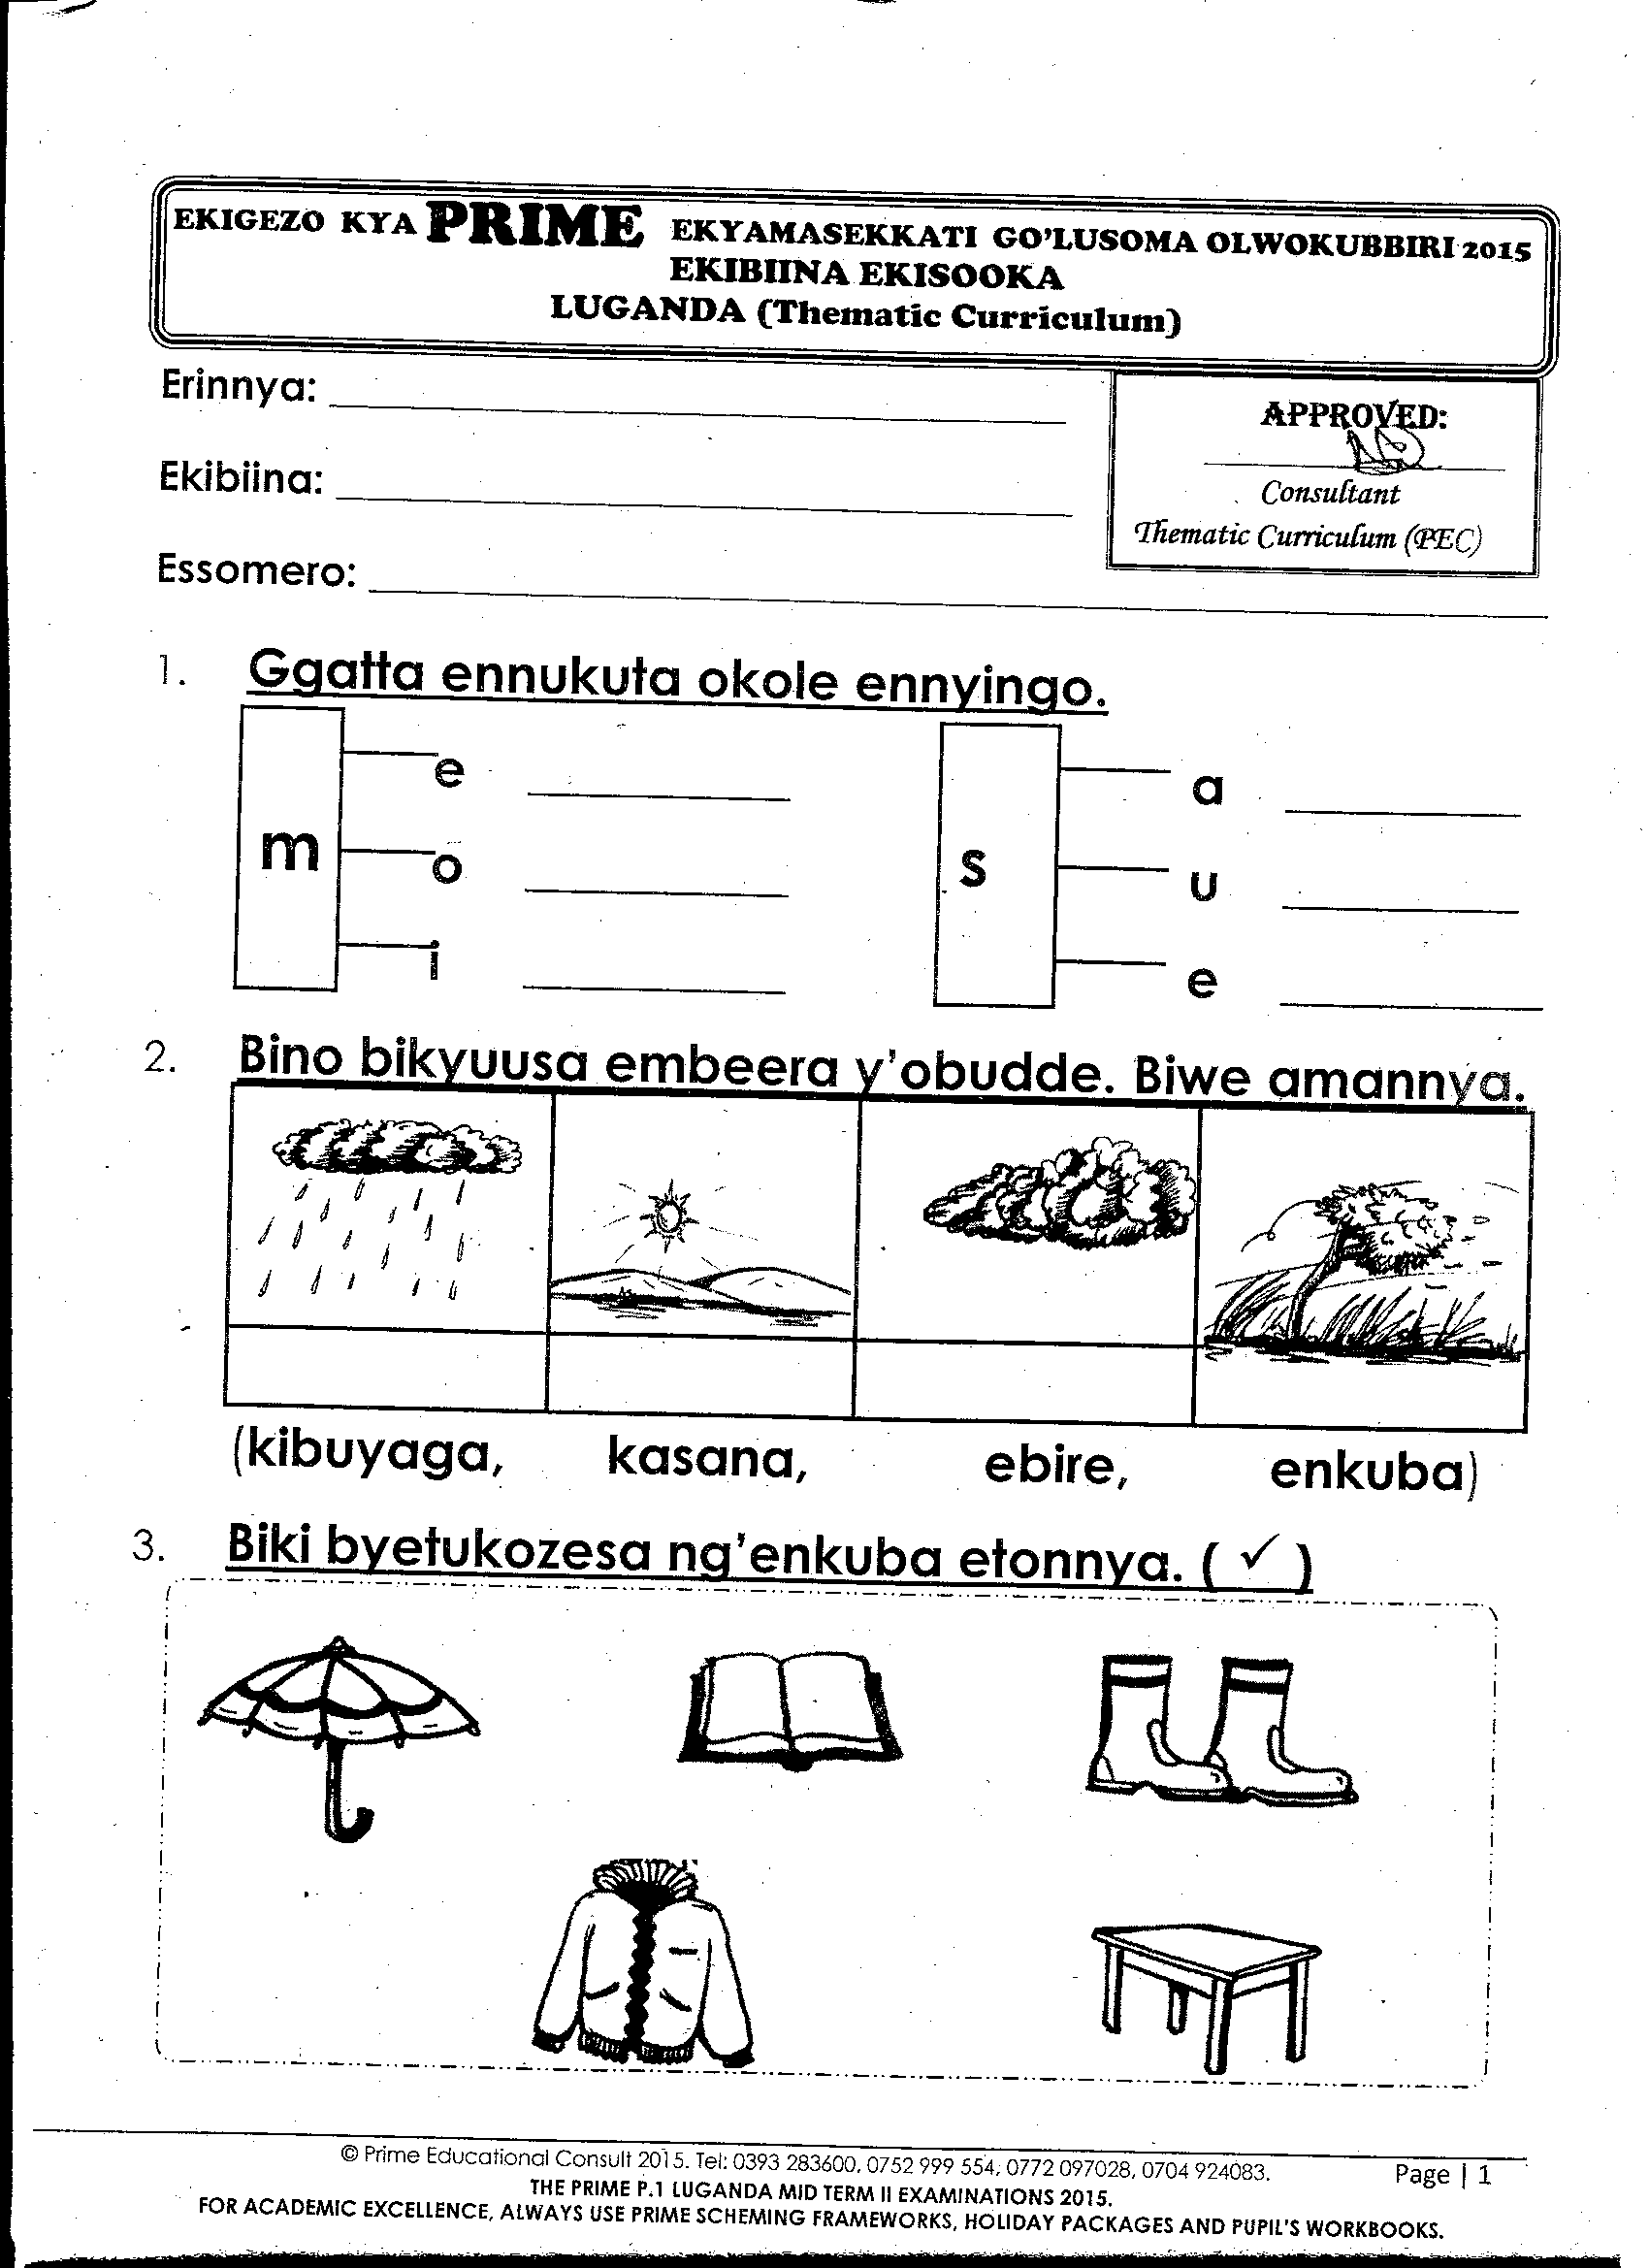  Match the same weather | - Matching  - Naming | Question and answer | Weather | Lfw page 22
8 | 2 | Identifying taking interest in and observing our environment | I can identify food that is good for my health. | I can tell the weather | Copy and draw the weather | - Copying  - Drawing | Question and answer | Weather | Lfw page 22
9 | 1 | Exploring and knowing immediate environment | I can identify people, plants and other things at the learning centre | I can talk about my family | Match the people found at home. | - Naming  - Matching | Look and say | A chart with the family members | Lfw page 20
9 | 2 | Exploring and knowing immediate environment |  | I can talk about my family | Copy and draw people found at home. | - Copying  - Drawing | Question and answer | A chart with the family members | Lfw page 20
  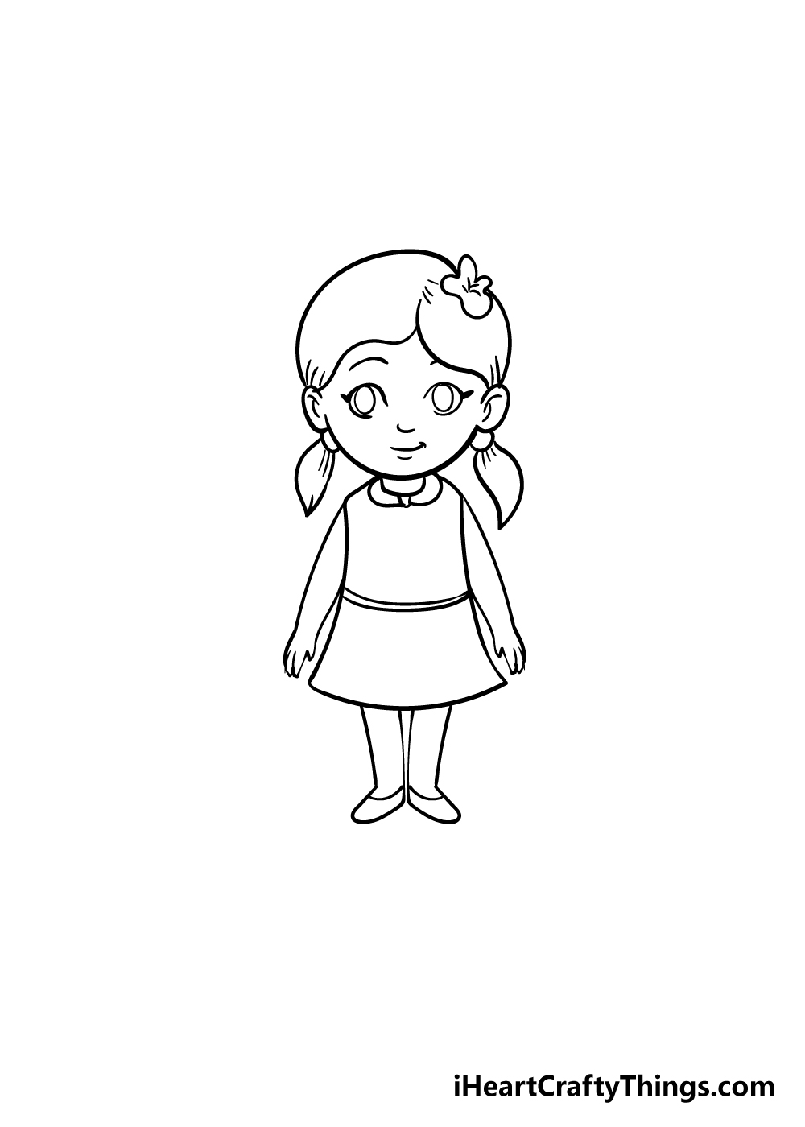 | 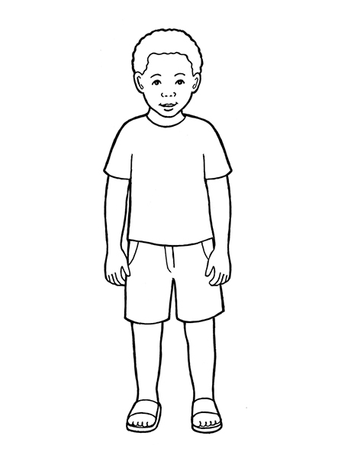 | 